IMPORTANT
Cut along the dotted lines and stick each box to your Datamax printer (Either side and on top)
Important instructions for easy reference, your employees will thank you!
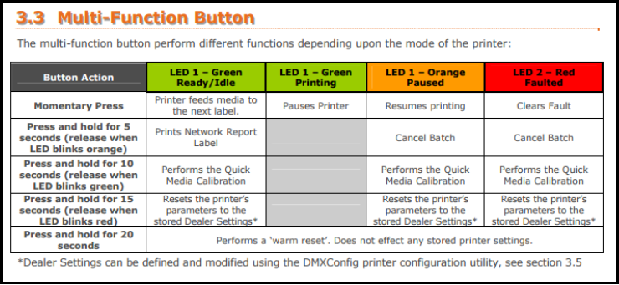

How to Calibrate the

Datamax Printer:
Press and hold «Play/Pause» button for 10 seconds
Then release when the LED light flashes green.
>> The printer will output 5-10 labels
>> The light LED light will be solid green

To ensure proper calibration:
- Press and release the «Play/Pause» button 3 times. If it is properly calibrated, only 1 label should come out each time (NOT 1.5 or 0.5 labels).
- Open the printer and roll the labels back in, they should stick out about 5mm.

You must Re-Calibrate

The printer if:
- The LED light is NOT solid green.
- The ribbon and/or labels are changed.
- If the label was pulled to hard from the printer in a way that de-calibrates the machine. Be careful when tearing.
- In case of major issues, restart the print «before» calibrating

For the Technician
IP Address: _______________________
Subnet Mask: _____________________
Gatway IP: ________________________

