# Datamax Driver Update Instructions

# (Recommended Version)

*The “Recommended Version” is best for practices that want their printer installed on their network so as to permit any computers in the practice to print labels on the Datamax printer.*

*We recommend that the steps below be performed by a computer technician or at a minimum, a person with patience and an intermediate knowledge of computer technology.*

## Calibrate your Datamax Printer

Prior to installing your printer on the network, ensure that the printer is turned on and properly calibrated. If your Datamax printer is properly calibrated, the indicator light will be a solid green.

To test if your printer is calibrated, press and release the Play/Pause button 3 times, each time 1 whole label should come out. *Not half or one and a half.*

*You may* [***click here***](https://www.youtube.com/watch?v=0Z9FTvcfvYc)*for a video on how to calibrate your Datamax printer.*

## ****Uninstall WINK Printer Driver****

* 1. Ensure the printer is plugged in, turned on and calibrated.
  2. Launch WINK and login to your account.
  3. Click **Settings** >> **Datamax Printer** >> **Uninstall WINK Printer Driver**
  4. Follow your on-screen prompts and click **"Yes"** to all three pop-ups (if they don’t pop-up, look in your taskbar for a flashing icon, and click on it).
  5. When the software has completed the un-installation, click on Settings and confirm that the “Uninstall WINK Printer Driver” option is in fact no longer available (uninstalled).
  6. **Exit** WINK Software.

## Datamax Tech Support: Request support for Installing Drivers and Configuring their Printer on your Network.

***Datamax Technical Support: 1-800-782-4263 >> #4 Tech Support >> #5 Datamax***

*Ask them to* walk you through the process of installing their Driver and Configuring their Printer on your network. Tell them:

* You are a WINK customer
* You want to install their printer on your network via **TCP-IP**
* How many Datamax printers you have to install (if more than 1, then they will each require a distinct name)
* You want to print labels on this printer from **many** computers in your practice (this is very important … repeat it often)
* You want them to help you install the printer on at least two computers.

**3.1 Print a Network Report:**

1. On the Datamax Printer, hold down the **“Play”** button for about 5 seconds >> release when the light flashes orange.
2. The printer should feed out a report with important information on it such as the **IP address, Gateway** & **Subnet Mask**.
   1. *You should write those three pieces of data down onto the document we recommend you stick onto the printer (see page 7).*
3. If this fails, another way to print your report is to click on **Start** >> **Control Panel** >> **Devices and Printers** >> Right click on the **Datamax Printer** >> ***Printer properties*** >> **Tools** >> **Printer** >> **Print** Dropdown >> **Configuration**.

*Provide this information to the Datamax Technical Support Representative.*

1. If this report simply won’t print out, your Datamax support representative may ask you to install special software to help you find that data another way. They may also request remote access to your PC. Simply follow their instructions.

**3.2 Install the Datamax Driver:**

1. Click on this link to download the driver required:<http://www.downloadwink.com/docs/do_7_3_4_M-0.exe>
   1. **Do NOT under any circumstance, install a different driver! Datamax support is trained to tell you to install the most recent version of their drivers. We’re not saying their latest driver won’t work, we’re just saying that we know that this one does work, and more importantly we know how it works.**
2. Follow the instructions provided by the Datamax Tech Support person.
3. Click on **“Run/Save”** and **'Accept the terms in the license agreement'** >> click **"Next"**
4. Click **“Next”** on the following prompt and then click **“Finished”**
5. Click **“Yes”** to any Windows prompts requesting that the program be permitted to make changes to your computer.
6. On the Seagull Driver Wizard screen, ensure the **“Install Printer Drivers”** is checked and click **“next”**
7. In the next window you may choose to set the printer as the default by checking the box. In this same window, ensure the **“Do not share this printer”** option is circled and click **“Next”**. Then click **“Finished”**. Be sure to allow any other Windows Prompts asking for permission to install or make changes.

**\* Before ending the call with Datamax,**

**Be sure to test the printer! \***

#### 3.3 To test if your driver is properly installed:

Click on **Start** >> **Control Panel** >> **Devices and Printers** >> Right click on the **Datamax Printer** >> ***Printer properties*** >> **Tools** >> **Action** >> **Form Feed**

**\*** This should feed out exactly 1 label. If it did, your driver is likely properly installed.

**\* WAIT … You’re not done yet!!!**

**The Driver must be downloaded, installed and TESTED on every**

**Computer that wants to print to that printer \***

* + 1. **Install the Datamax Driver on ALL remaining computers:**
    2. Go to second computer, and download the Datamax driver again by clicking on this link: <http://www.downloadwink.com/docs/do_7_3_4_M-0.exe>.
    3. The screen shots below are provided for purpose of guidance. You may ask the Datamax Support Representative to stay on the line with you until you’ve completed the steps and are able to print from another computer.
    4. After the driver has downloaded, and you’ve run it >> **Accept** the Terms and Conditions and click **“Next”**

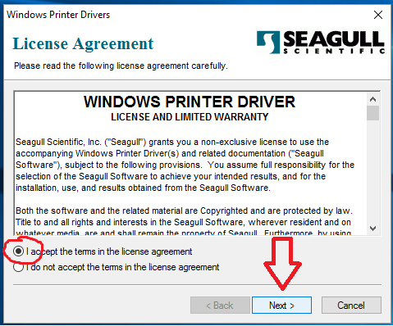

**d)** Click **“Next” e)** Click **“Finished”**

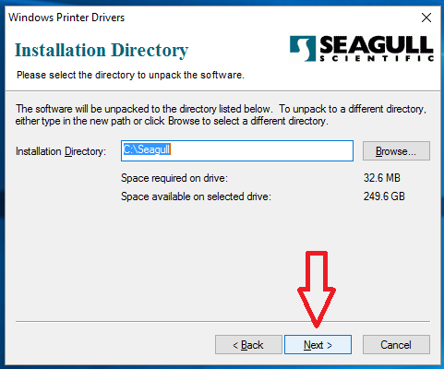 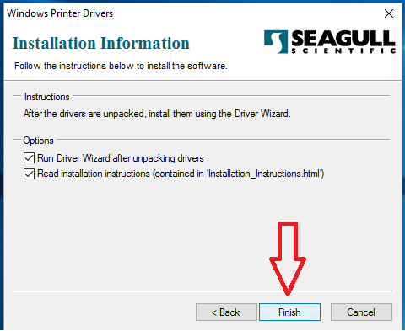

**f)**  Ensure “**Install Printer Drivers”** is selected **g)** Select **“Network”** and click **“Next”**

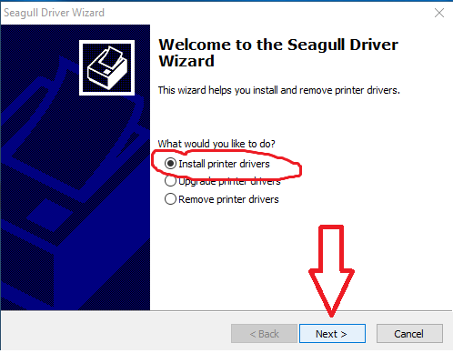 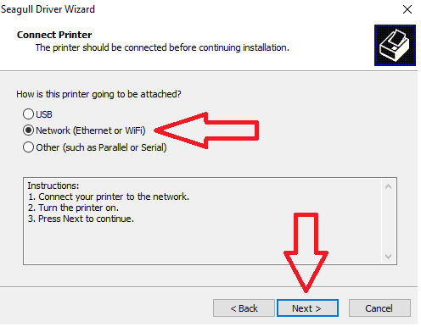

**h)**  Select the “**Printer Model”** and click **“Next” i)** Click on **“Create Port”** 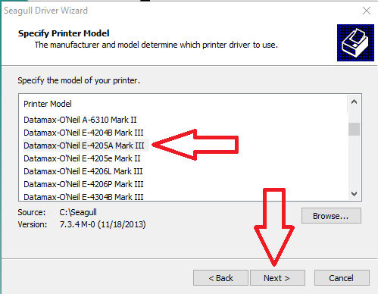 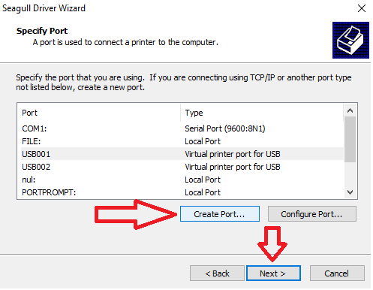

**j)** Select **“Stdrd TCP/IP Port”** & click **“New Port” k)** Click **“Next”**

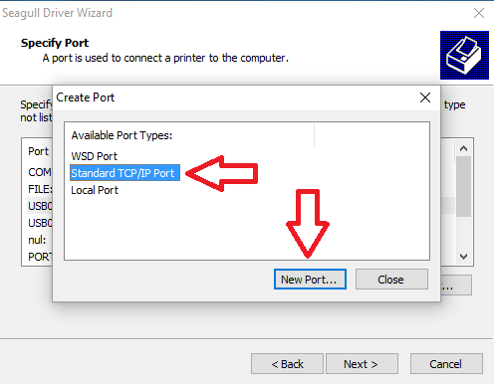 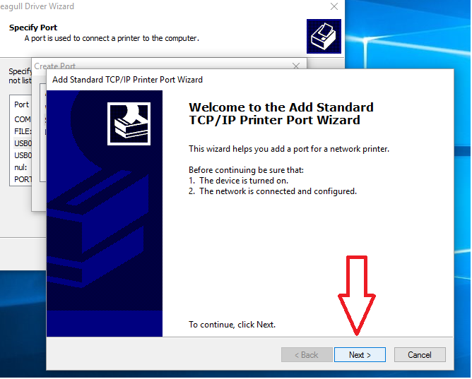

**l)** Enter your printers **IP** address>> Click **“Next” m)** Click **“Next”**

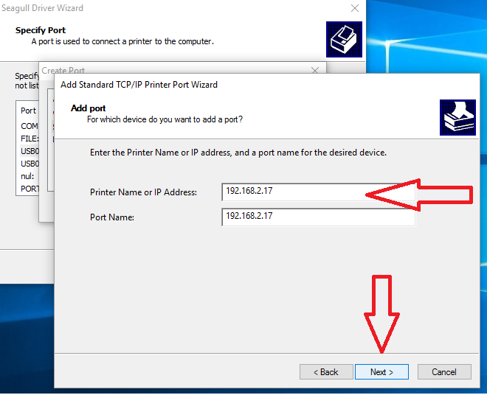 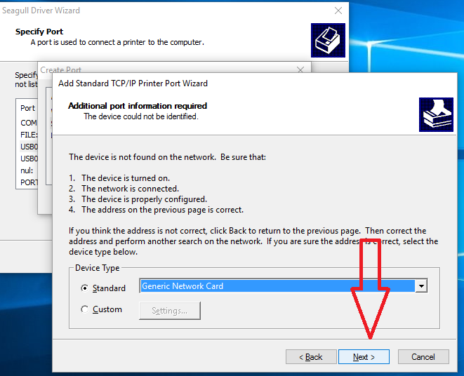

*The address above, is likely not “your” printer’s*

*IP address. It was however ours.*

**n)** Click **“Finish”**

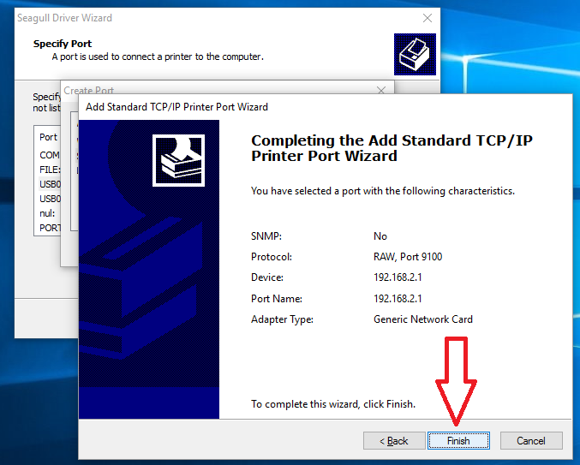

## ****Configure Printer Settings *(must be done on all computers)*****

1. Click on your **Start** menu >> **Devices and Printers** >> Right click the **Datamax-O’Neil** icon >> **Printer Properties**
2. Click on the **“General”** tab >> **Preferences** *(new window appears)*
3. Click on the **Page setup** tab   
   **Stock:** Click **"New"** >> Name field, Type: **"WINK Frame Label"** >> **Label Size :**
   1. **W: 2.50 in** >> **H: 1.25 in**
   2. **Exposed Liner Width L: 0.05 in** >>  **R: 0.05 in** >> **OK**
   3. **Orientation:**   **Landscape**
4. Click on the **Options** tab  
   **Print Head Temperature**: Check the box **“Send with job”** and set to 20 by moving the slider to the right (the higher the setting, the darker the printing will be).
5. Click **Apply** >> **OK** *(window disappears/back to Properties)*
6. Click on the **“Advanced”** tab >> **Printing Defaults** *(new window appears)*
7. Click on the **Page setup** tab  
   **Stock:** Click **"New"** >> Name field, Type: **"WINK Frame Label"** >> **Label Size :**
   1. **W: 2.50 in** >> **H: 1.25 in**
   2. **Exposed Liner Width L: 0.05 in** >>  **R: 0.05 in** >> **OK**
   3. **Orientation:**   **Landscape**
8. Click on the **Options** tab  
   **Print Head Temperature**: Check the box **“Send with job”** and set to 20 by moving the slider to the right (the higher the setting, the darker the printing will be).
9. Click **Apply** >> **OK** *(window disappears/back to Properties)*
10. *You probably noticed that we asked you to do this twice. That was on purpose.* ***Trust us!***

## Configure WINK Settings *****(must be done on all computers)*****

1. Launch **WINK** and Login
2. In the menu bar at the top of the screen, click on **Settings** >> **Printers and Trays**
3. In the Printer column: Replace the **Datamax-WINK** driver with the **Datamax O’Neill** Driver as the default location for all labels
4. In the **Tray column**: Select **Continuous Scroll** as the default tray for all labels
5. Click **Save** >> **OK** >> **Close** the page
6. Set your **Frame Label Format**:

**Settings** >> **Frame Label Format** >> and adjust the lines accordingly.

We recommend as follows:

* 1. Line 1: **Brand**
  2. Line 2: **Model**
  3. Line 3: **Color and Size**
  4. Line 4: **Price**
  5. Click **Save** >> **OK**

**Your Datamax printer should now be setup and you can test it by printing a label.**

* Please note that the first label printed from every computer everyday may take 10 seconds to feed out. This is completely normal. All subsequent labels will print out 1-2 seconds after you click on print

If all is setup properly, your label should look something like this:

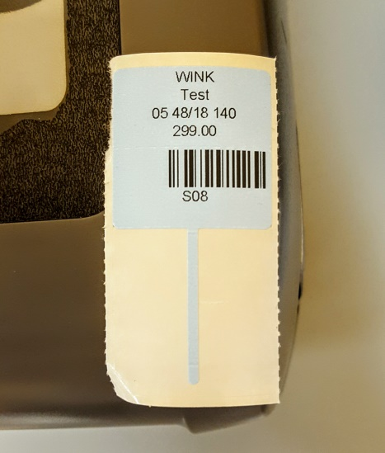

Notice how all the data is centered, but the barcode is right justified?

This is normal; we cannot control it. All barcodes will appear right justified.

**Please print out** [**this document**](http://www.downloadwink.com/docs/Datamax_Calibration_EN-20160412.docx) **as it contains the calibration instructions needed for your printer. We’ve even made it easy for you! Simply print and cut along the dotted lines and stick to either side of the printer! Be sure to write down the IP address in the provided area ☺**

**If you want the instruction manual for your printer, you can find it** [**here**](https://www.datamax-oneil.com/do/com/en-us/home/support-downloads/downloads-drivers&p=40CAF421-B55C-42B1-F89349B494463F15#SM1)

**Happy Printing!**